- DS18B20 Soil Temperature
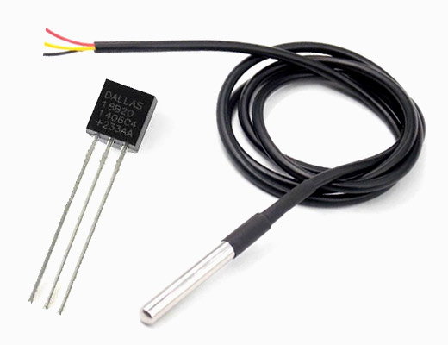
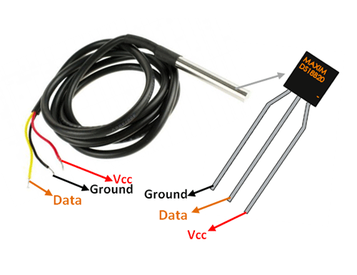

DESCRIPTION
This is a pre-wired and waterproofed (with heat shrink) version of the DS18B20 sensor. Handy for when you need to measure something far away, or in wet conditions. While the sensor is good up to 125°C the cable is jacketed in PVC so we suggest keeping it under 100°C. Because they are digital, you don't get any signal degradation even over long distances! These 1-wire digital temperature sensors are fairly precise (±0.5°C over much of the range) and can give up to 12 bits of precision from the onboard digital-to-analog converter. They work great with any microcontroller using a single digital pin, and you can even connect multiple ones to the same pin, each one has a unique 64-bit ID burned in at the factory to differentiate them. Usable with 3.0-5.0V systems.

Pin Configuration
No: | Pin Name | Description
1 | Ground | Connect to the ground of the circuit
2 | Vcc | Powers the Sensor, can be 3.3V or 5V
3 | Data | This pin gives output the temperature value which can be read using 1-wire method

DS18B20 Sensor Specifications
- Programmable Digital Temperature Sensor
- Communicates using 1-Wire method
- Operating voltage: 3V to 5V
- Temperature Range: -55°C to +125°C
- Accuracy: ±0.5°C
- Output Resolution: 9-bit to 12-bit (programmable)
- Unique 64-bit address enables multiplexing
- Conversion time: 750ms at 12-bit
- Programmable alarm options
- Available as To-92, SOP and even as a waterproof sensor
Note: Read further to know why these parameters are important. Also the DS18B20 datasheet can be found at the bottom of the page

Where to use DS18B20 Sensor
The DS18B20 is a 1-wire programmable Temperature sensor from maxim integrated. It is widely used to measure temperature in hard environments like in chemical solutions, mines or soil etc. The constriction of the sensor is rugged and also can be purchased with a waterproof option making the mounting process easy. It can measure a wide range of temperature from -55°C to +125° with a decent accuracy of ±5°C. Each sensor has a unique address and requires only one pin of the MCU to transfer data so it a very good choice for measuring temperature at multiple points without compromising much of your digital pins on the microcontroller.

How to use the DS18B20 Sensor
The sensor works with the method of 1-Wire communication. It requires only the data pin connected to the microcontroller with a pull up resistor and the other two pins are used for power as shown below.
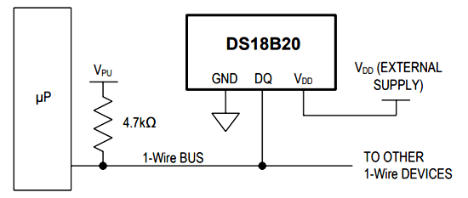
The pull-up resistor is used to keep the line in high state when the bus is not in use. The temperature value measured by the sensor will be stored in a 2-byte register inside the sensor. This data can be read by the using the 1- wire method by sending in a sequence of data. There are two types of commands that are to be sent to read the values, one is a ROM command and the other is function command. The address value of each ROM memory along with the sequence is given in the datasheet below. You have to read through it to understand how to communicate with the sensor.

Applications
- Measuring temperature at hard environments
- Liquid temperature measurement
- Applications where temperature has to be measured at multiple points

Installing Library For DS18B20
The Dallas 1-Wire protocol is somewhat complex, and requires a bunch of code to parse out the communication. To hide away this unnecessary complexity we will install DallasTemperature.h library so that we can issue simple commands to get temperature readings from the sensor.
To install the library navigate to the Sketch > Include Library > Manage Libraries…Wait for Library Manager to download libraries index and update list of installed libraries.

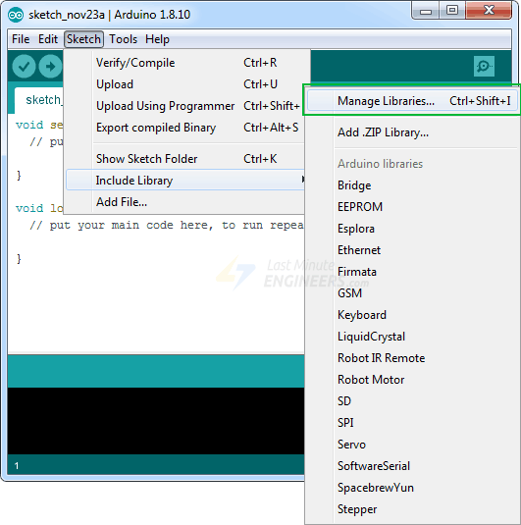

Filter your search by typing ‘ds18b20’. There should be a couple entries. Look for DallasTemperature by Miles Burton. Click on that entry, and then select Install.
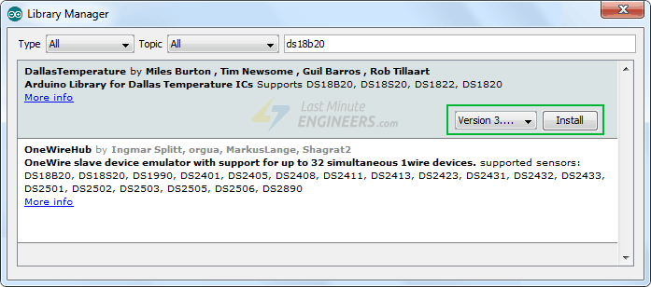
This Dallas Temperature library is a hardware-specific library which handles lower-level functions. It needs to be paired with One Wire Library to communicate with any one-wire device not just DS18B20. Install this library as well.
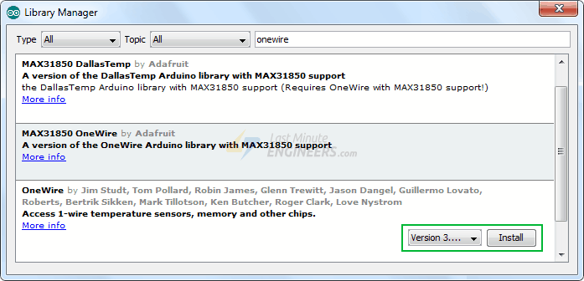

Arduino Code
The following sketch will give you complete understanding on how to read temperature readings from DS18B20 Temperature Sensor and can serve as the basis for more practical experiments and projects.
#include <OneWire.h>
#include <DallasTemperature.h>

// Data wire is plugged into digital pin 2 on the Arduino
#define ONE_WIRE_BUS 2

// Setup a oneWire instance to communicate with any OneWire device
OneWire oneWire(ONE_WIRE_BUS);

// Pass oneWire reference to DallasTemperature library
DallasTemperature sensors(&oneWire);

void setup(void)
{
sensors.begin(); // Start up the library
Serial.begin(9600);
}

void loop(void)
{
// Send the command to get temperatures
sensors.requestTemperatures();

//print the temperature in Celsius
Serial.print("Temperature: ");
Serial.print(sensors.getTempCByIndex(0));
Serial.print((char)176);//shows degrees character
Serial.print("C | ");

//print the temperature in Fahrenheit
Serial.print((sensors.getTempCByIndex(0) * 9.0) / 5.0 + 32.0);
Serial.print((char)176);//shows degrees character
Serial.println("F");

delay(500);
}
Here’s how the output looks like in the serial monitor.
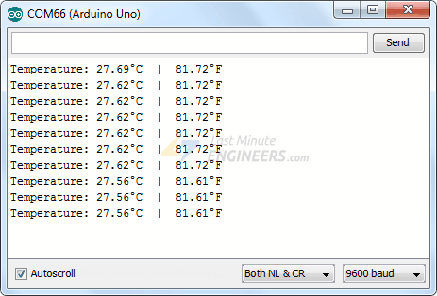

Code Explanation:
The sketch starts by including OneWire.h and DallasTemperature.h libraries and declaring the Arduino pin to which the sensor’s signal pin is connected.
#include <OneWire.h>
#include <DallasTemperature.h>

#define ONE_WIRE_BUS 2
Next we create a one-wire object by passing sensor’s signal pin to its constructor. This one-wire object let’s us communicate with any one-wire device, not just DS18B20. In order to communicate with DS18B20 sensor, we need to create object of DallasTemperature library and pass reference of one-wire object as a parameter.
OneWire oneWire(ONE_WIRE_BUS);
DallasTemperature sensors(&oneWire);
Once a DallasTemperature object is created, we can issue below simple commands to interact with the sensor.
- begin() function searches for connected sensors on the bus and sets bit resolution (12 bits) for each.
- requestTemperatures() function sends command for all sensors on the bus to perform a temperature conversion.
- getTempCByIndex(deviceIndex) function reads and returns temperature reading from the sensor. deviceIndex is nothing but the location of the sensor on the bus. If you are using only one DS18B20 on the bus, set it to 0.

Other useful functions in DallasTemperature.h library
There are a few useful functions you can use with DallasTemperature object. Few of them are listed below:
- setResolution() function sets resolution of internal Analog-To-Digital converter of DS18B20 to 9, 10, 11, or 12-bits, corresponding to increments of 0.5°C, 0.25°C, 0.125°C, and 0.0625°C, respectively.
- bool getWaitForConversion() function returns the value of the waitForConversion flag. It can be useful when you want to check whether a temperature conversion is complete.
- setHighAlarmTemp() & setLowAlarmTemp() function sets the internal high & low temperature alarms for a device in degrees Celsius. Valid range is -55 to 125°C
- bool hasAlarm() function returns true if device have an alarm condition when temperature exceeds high & low alarm temperature setting.

